Transition Reads
Getting ready for Year 7? Try one of these books

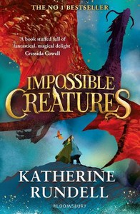
Impossible Creatures by Katherine Rundell
A boy called Christopher is visiting his reclusive grandfather when he witnesses an avalanche of mythic creatures come tearing down the hill. This is how Christopher learns that his grandfather is the guardian of one of the ways between the non-magical world and a place called the Archipelago: a cluster of magical islands, where all the creatures we tell of in myth live and breed and thrive alongside humans. They have been protected for thousands of years from being discovered; now, terrifyingly, the protection has worn thin, and creatures are breaking through.
Then a girl, Mal, appears in Christopher’s world. Together the two must face the problem of power, and of knowledge, and of what love demands of us.

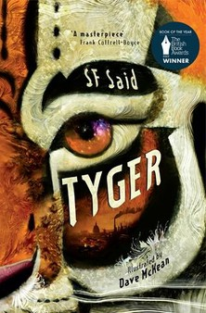
Tyger by SF Said
Adam has found something incredible in a rubbish dump in London. A mysterious, mythical, magical animal. A Tyger. And the tyger is in danger.
Adam and his friend Zadie are determined to help, but it isn't just the tyger's life at stake. Their whole world is on the verge of destruction. Can they learn to use their powers before it's too late?

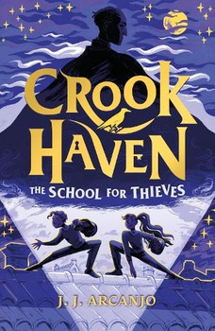
Crookhaven The School of Thieves by JJ Arcanjo
13-year-old Gabriel is a brilliant pickpocket, a skill which he uses to keep his often empty belly not quite so empty. And then one day, he's caught.
But instead of being arrested, he is invited by the mysterious Caspian Crook to attend Crookhaven - a school for thieves. At Crookhaven, students are trained in lock-picking, forgery and 'crim-nastics', all with the intention of doing good out in the world, by conning the bad and giving back to the innocent.
But ... can you ever really trust a thief? With a school wide competition to be crowned Top Crook and many mysteries to uncover, Gabriel's first year at Crookhaven will be one to remember.

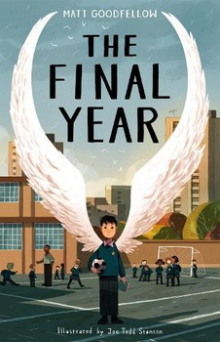
The Final Year by Matt Goodfellow
Life can be tough in your last year of primary school. Tests to take, preparing for the change to high school. Nate is ready for it all, knowing his best friend PS is at his side - they've been inseparable since Nursery.
But when they are put in two different classes and PS finds a new friend in Turner, the school bully, Nate's world turns upside-down. As he struggles to make sense of this and forge new friendships, he's dealt another blow when his youngest brother, Dylan is rushed into hospital.
His new teacher, Mr Joshua, sees a spark inside of Nate that's lit by his love of reading and writing and shows him how to use this to process what's going on. But with so much working against him, and anger rising inside him, will this be enough?
A powerful and lyrical story about finding your place in the world and the people that matter within it.

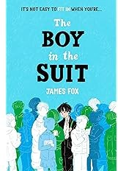
The Boy in the Suit by James Fox
It's not easy to fit in when you're the boy in the suit... Ten-year-old Solo - embarrassingly, that isn't short for anything - just wants to be normal.
He wants a name that doesn't stand out. He wishes he had a proper school uniform that fitted him. He dreams about a mum who doesn't get the Big Bad Reds, like his mum Morag.
But most of all he longs to stop crashing funerals for the free food. But when Solo and Morag crash the funeral of a celebrity and get caught, the press are there to witness their humiliation. The next day it's splashed across the papers. Before Solo knows it, he becomes a viral sensation, and life may never be normal again.
A sensitive, empathetic, timely portrayal of a family struggling during the cost of living crisis. This extraordinary debut will make you laugh and cry.

