


PLYMSTOCK SCHOOL

PERSONNEL RECRUITMENT

SCIENCE DEPARTMENT

Broad and balanced Science for all is a feature of the Science taught at Plymstock School.

The department is actively addressing the National Curriculum in terms of content and assessment at both Key Stage 3 and Key Stage 4. All staff are expected to contribute towards the production and fine-tuning of schemes of work and to be actively involved in the assessment and moderation of students’ work.

Plymstock School has a 25 period week of one hour lessons operating over a 2 week timetable. Students are allocated 6-7 periods of Science in years seven, eight and nine; 9 periods at Key Stage 4; and 10 periods in Key Stage 5.

We offer AQA triple science, Science A and Additional GCSE, Edexcel BTEC in Applied Science and Health and Social Care at KS4. At KS5 we offer OCR AS and A2 level Biology, Chemistry and Physics, AQA AS level Electronics and BTEC National Applied Science Level 3. We also offer Health and Social Care to A Level.

KEY STAGE 3
We follow a two year course that is based on the Exploring Science topic-based course. Students are regularly assessed by end of module/topic written tests which are linked to APP assessment foci and recorded centrally. The students are taught in ability groups and all staff are expected to teach across the full ability range. KS3 topics have been condensed so that students cover all of the work for KS3 in Years 7 & 8 and begin their KS4 in Year 9. We currently have 2 Year 9 classes taking triple science.

KEY STAGE 4
In Year 10, most students take AQA GCSE Science A, followed by Additional Science in Year 11. We have two classes in Year 10 and two in Year 11 taking triple science. Some foundation students follow the Edexcel BTEC in Applied Science at Level 2. We also offer Health and Social Care.

KEY STAGE 5
In the Sixth Form, AS and A2 Levels in Biology, Chemistry and Physics are successfully taught to large numbers, (often 2 classes of more than 15 students each) with extremely high pass rates being achieved. The department also offers Level 3 BTEC National Applied Science and Health and Social Care.

DATA LOGGING
We have heavily invested in data-logging equipment for the department. We presently have 30 designated lap-tops with numerous sensors.

PRIMARY LIAISON
We enjoy strong links with our feeder primary schools and particularly with Elburton and Goosewell Primary Schools.

SMART BOARDS
Each laboratory has a projector and most have interactive Smart Boards.

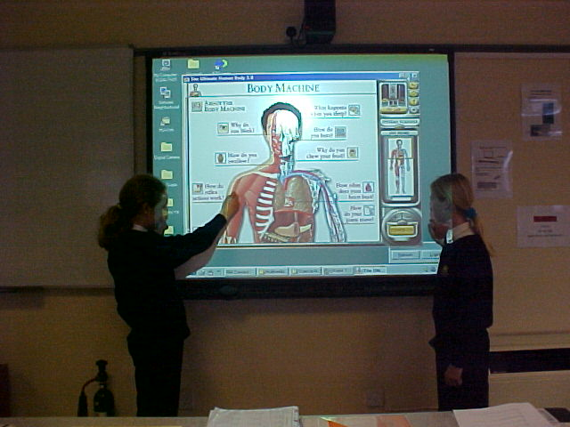

Year 8students using a Smart Board

ACCOMMODATION
The Science Department is the largest in the School and is accommodated in twelve well-equipped laboratories and a dedicated computer suite. The department has twelve teachers, three technicians, and administrative staff, each with considerable expertise, providing excellent opportunities for students of all ages.

We are a Department committed to excellence in the teaching of Science and we aim to encourage all students to achieve their potential. More information about Plymstock School can be found on our website www.plymstockschool.org.uk.

Any science specific questions may be directed to the Head of Science by e-mail at rbaker@plymstockschool.org.uk.

Bob Baker
HEAD OF SCIENCE
March 2014



